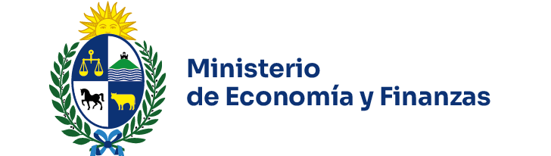


Press Release of the Public Debt Coordination Committee (PDCC)

On July 4, 2025, the Public Debt Coordination Committee (PDCC), comprising the Ministry of Economy and Finance (MEF) and the Central Bank of Uruguay (BCU), convened a meeting.

During the session, the following topics were discussed:

Assessment of the sovereign bond issuance in the Swiss market

The Committee highlighted the results of the recent issuance carried out by the Government in the Swiss market, consisting of two global bonds totaling CHF 320 million (equivalent to USD 400 million), with maturities of 5 and 10 years. The discussion underscored the advantages of opening a new funding source, which contributes to further diversifying the investor base and enhancing financial flexibility for cost optimization and liability management, alongside traditional international debt markets (in local currency and US dollars).

Review of the local market issuance calendar and guidelines for the second half of 2025

The Committee reviewed the outcomes of the issuance program for the first half of the year, highlighting the strong demand across all three types of local currency instruments. The meeting also emphasized the use of the integration mechanism with Central Bank Monetary Regulation Bills, which has facilitated progress in asset and liability management across the public sector. In particular, during the first half of the year, 44% of total Treasury Note issuances by the Government were settled using BCU Bills.
The MEF shared and discussed with the BCU the primary factors and criteria considered in designing the issuance calendar for the second half of 2025: (i) the evolution of investor demand (in terms of maturities, amounts, and currencies), (ii) the Government’s financing objectives, (iii) the compression of short-term bill rates and the monetary policy strategy within the consolidation of the inflation-targeting regime, and (iv) the domestic and international context. In this regard, both institutions exchanged views on investors’ preferences for nominal fixed-rate instruments with maturities under five years, in a context of significantly declining inflation and inflation expectations, as well as a weakening of the US dollar globally. Structural aspects, such as the maturing of the pension system and its impact on the demand for government securities, were also discussed. The Committee agreed on the importance of the Government securing financing at rates consistent with progress in reducing inflation and achieving fiscal sustainability. Additionally, it emphasized the relevance of maintaining financial flexibility within the issuance calendar, including the amounts to be issued, eligible instruments for exchange operations, and auction mechanisms.

The Committee also emphasized the importance of continuing to promote the dynamics of the primary and secondary markets for local securities through investor presentations jointly organized by both institutions, as well as through the regular dissemination of auction results. These actions aim to enhance transparency and provide analytical inputs for both resident and non-resident investors, thereby fostering greater participation, depth, and efficiency in the local market to the benefit of all participants.

Finally, the MEF and BCU agreed on the importance of continuing to jointly monitor local debt markets and coordinate the implementation of their respective financing and sterilization policies, particularly along the short end of the public debt yield curve.

The next meeting of the Committee is scheduled for September 2025.

